# USER-MANUAL GUIDE FOR ADMIN/STAFF AND USER/PATIENT, BOTH IN ONE

# Contents

**Introduction ….......................................................................3**

**Manual's Objective................................................................3**

**HOW to STEPS.......................................................................3**

**For the STAFF /ADMIN............................................................................3**

**How to register?............................................................................3**

**How to login?................................................................................4**

**How to navigate the system after logging in successfully?.............5**

**For the PATIENT.............................................................8**

**How to register?............................................................................8**

**How to login?................................................................................9**

**How to navigate the system after logging in successfully?............10**

**Introduction**

This Laboratory Management System was created for the purpose of making the workflow of managing the innerworkings of a laboratory management system smoother.

This Laboratory Management System (LMS) is a software system that helps manage the operations of a medical laboratory. It can help with tasks such as tracking patient data, managing inventory, and automating workflows. The primary objective of the LMS is to improve the quality of patient care by ensuring that laboratory results are accurate, reliable, and delivered in a timely manner. By automating many of the tasks involved in laboratory management, these systems can help reduce errors and improve efficiency.

The system is designed to allow the patients who have been registered to the system to view their information on the medical test orders they've already placed, their personal payment information and view their test results from the comfort of their homes .It helps to minimize frequent visits to hospitals thereby reducing time wasted on ,commutes related to procuring your test results and the daily mundane procedural interactions that we go through with the hospital staff that we all know we can live without. It also saves time for the staff as there's no need to have to put in a call every time a patient's results are out as the information will be displayed on the patient's screens as soon as the results come out.

All in all, the advantages of reducing tasks as well as patient result mix-ups, the need for lesser staff, quick and simple to follow procedures, user-friendliness and its environmentally friendly attribute as there's no need for paperwork all attest to all the reasons why this system is beneficial.

**Manual's Objective**

This manual serves as a guide and reference for the use of the Laboratory Management system (LMS). This user manual helps users to familiarize themselves with the web app and to use all its potential.

It includes the information on the system such as the features and operation of the product which will educate, assist and satisfy the user.

**HOW to STEPS**

**For the STAFF /ADMIN**

**How to register?**

* Open the registration form
* Insert name, email, password and confirm your password to the allocated space
* Click on the Dropdown icon and choose admin
* Click ***register now***
* The user is now registered successfully!

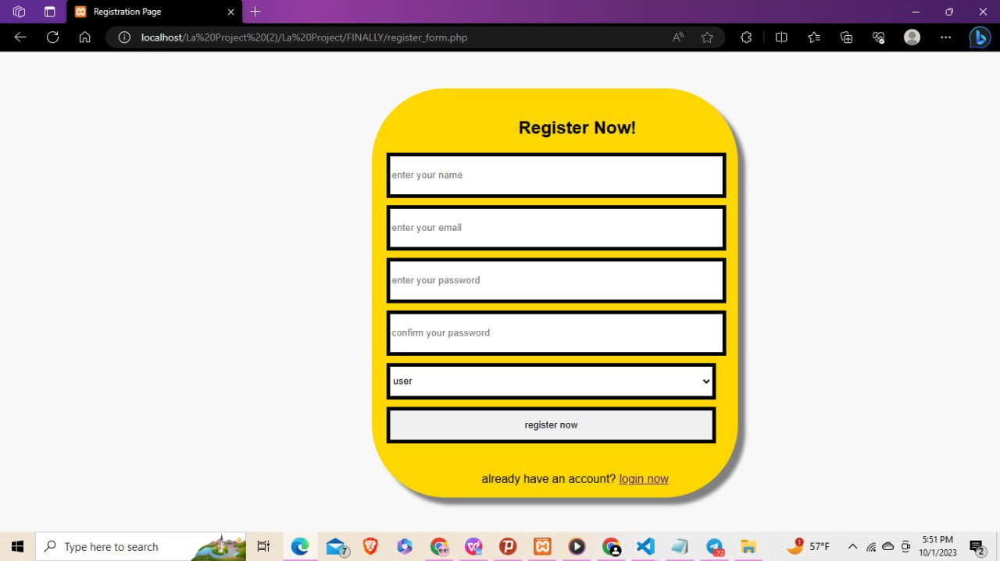

-if the staff is already registered you can click on ***login now*** Found at the very bottom of the form.

**How to login?**

* Open the login form
* Insert your password and email in the allocated space
* Click ***login now***

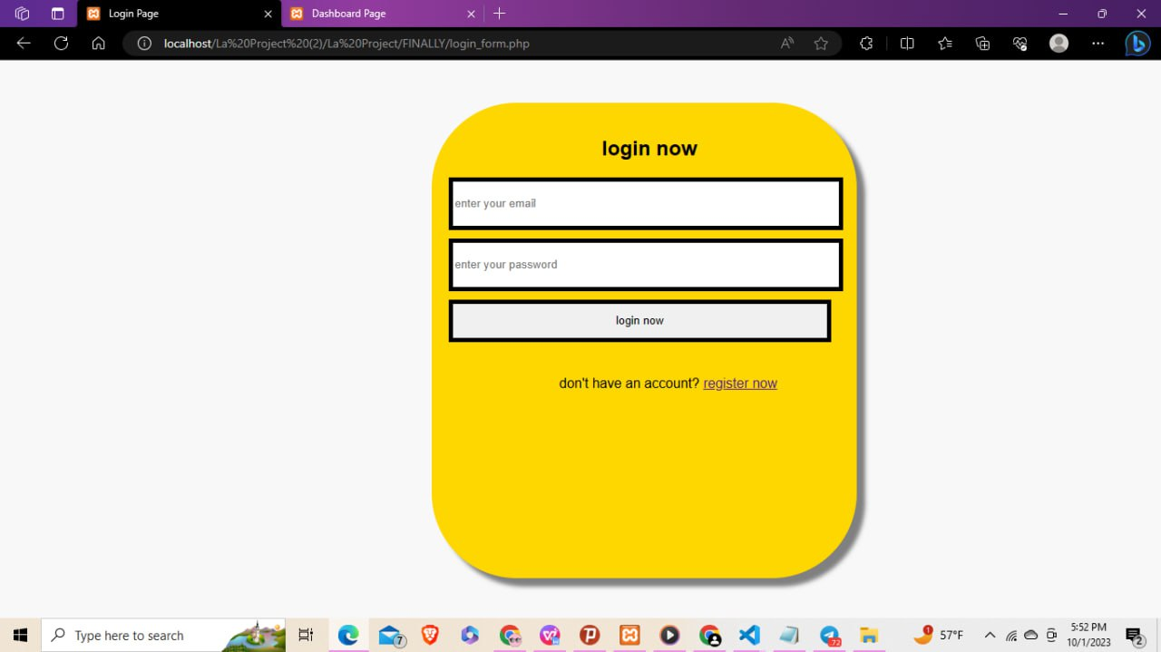

-if the there's a problem try resubmitting your form (*error warning: incorrect password or email*) or

Register by clicking ***register now*** If you haven't registered yet

* The website now leads to the dashboard curated for the patient/user.

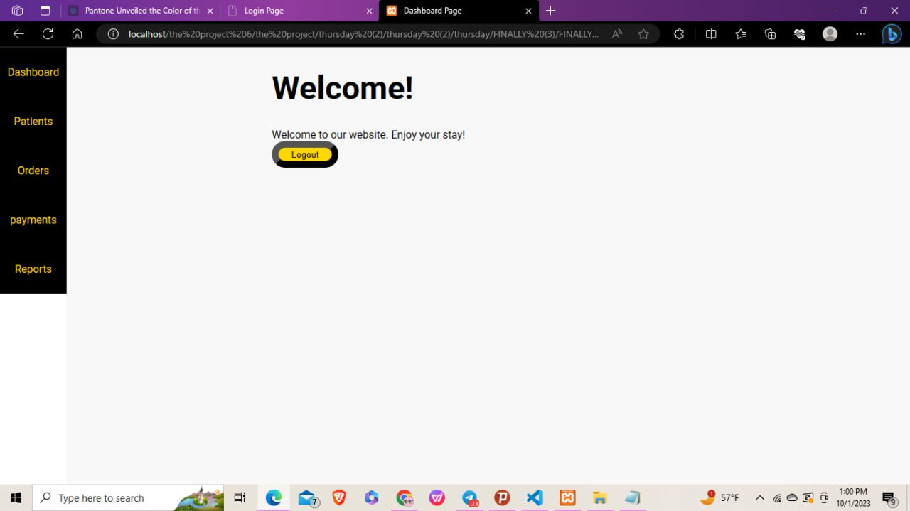

**How to navigate the system after logging in successfully?**

* The menu and the welcome page from the dashboard menu are now on display
* Clicking the ***logout*** button in the dashboard section leads back to the login form
* Click the ***patients*** section in the navigation bar where every patient and information on the patients’ ID, patient Name, Email, age, address, who registered for a lab test so far is in display

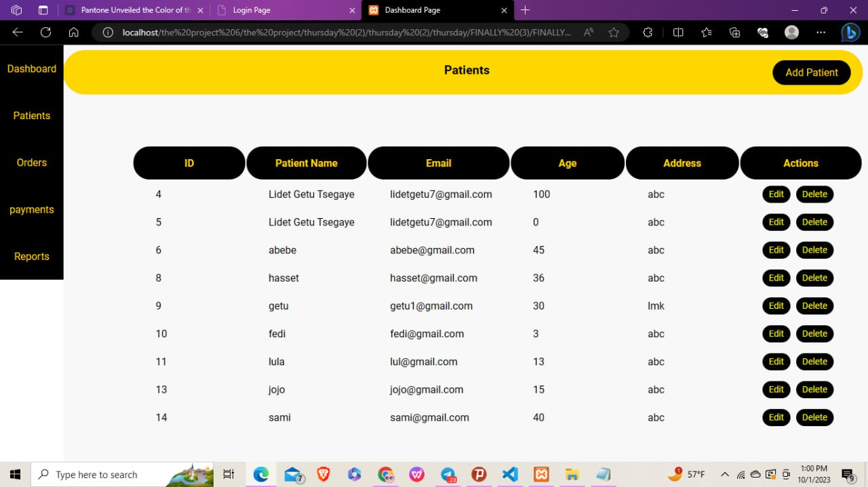

- the ***action*** column contains ***update*** and ***delete*** buttons that enable us to edit the already existing patient's information and delete the specified patient's information respectively when clicked

-the ***add patient*** button found on the upper left of the screen performs the function of adding new patient information

* Click ***add patient***
* Fill out the patient's information
* Click ***submit*** which leads back to the patients table

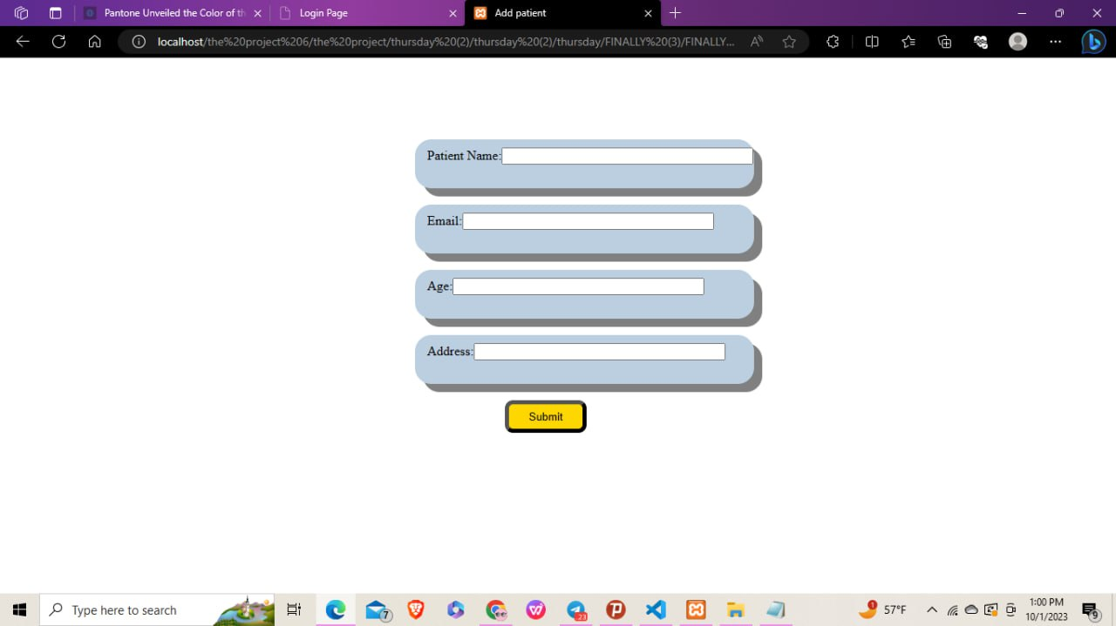

* Click the ***orders*** section found on the navigation bar where every lab test ordered containing information on the id of the patient, test name, unit and cost of the test, for patients that have been added on the prior stage is on display

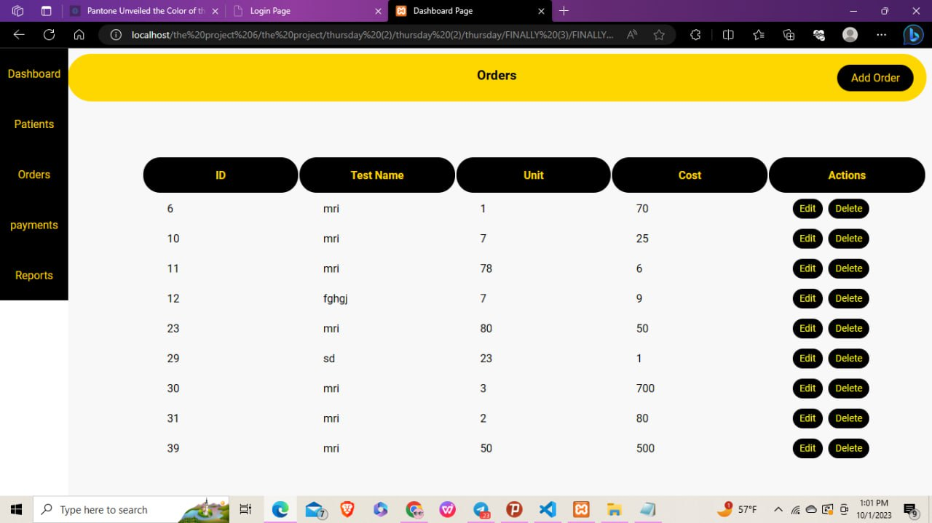

-the ***action*** column contains ***update*** and ***delete*** buttons that enable us to edit the already existing order information and delete the specified order information respectively when clicked

- the ***add order*** button located on the upper left corner of the screen performs the function of adding new test order

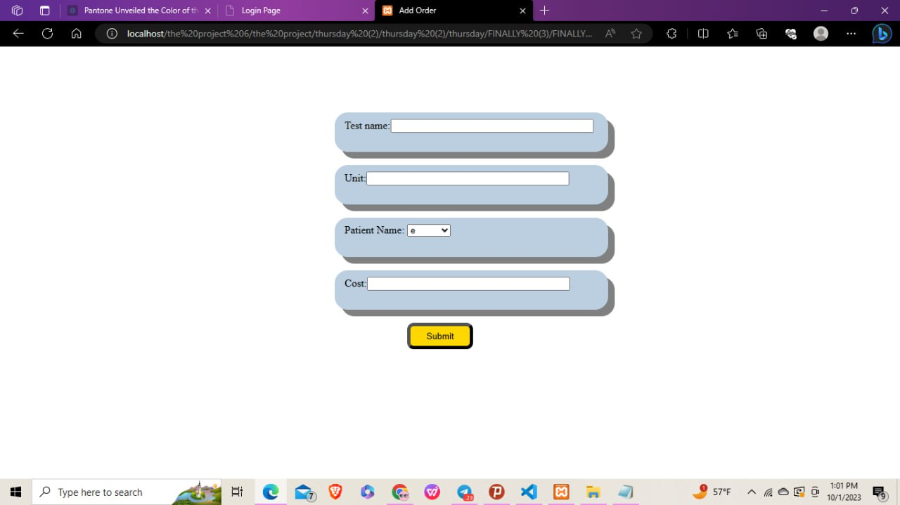

* Click ***add order***
* Fill out the test information

-the dropdown choice only contains patients that have their information inputted in the ***add patient's*** button found on the patient's menu

* Click ***submit*** and you'll be redirected back to the orders table

- the information you just inserted will now be displayed on the patients front table display

* Click the ***payment*** section in the navigation bar where the payment information including the patient's id, full test name, units, cost and payment settlement for the orders taken so far is on display

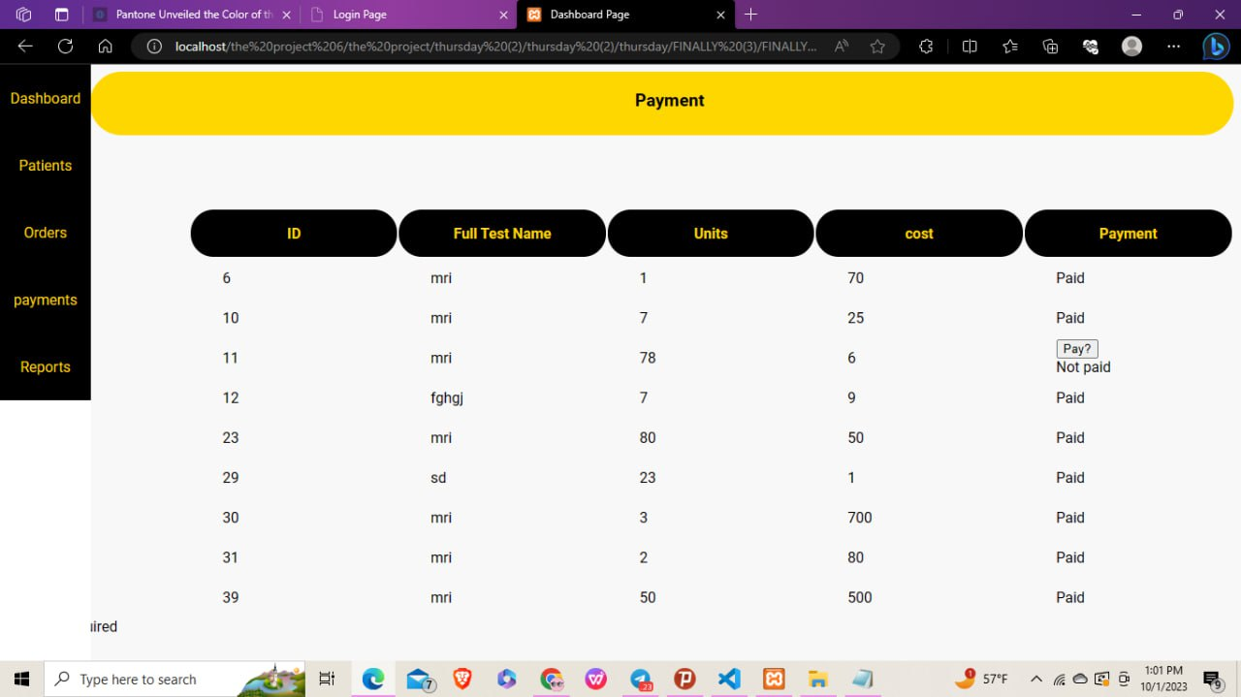

* click on the ***pay?*** Button found on the payment column when the patient pays their fee
* Click the ***results*** section in the navigation bar which displays an input form for entering

information regarding the test results

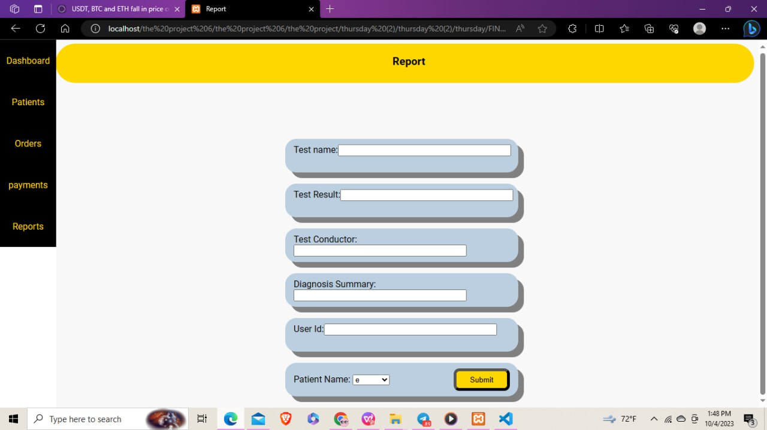

* Enter the information on the input form
* Click ***submit***

- the results will automatically be displayed on the result section of the user/patient's system

**For the PATIENT/USER**

**How to register?**

* Open the registration form
* Insert name, email, password and confirm your password to the allocated space
* Click on the Dropdown icon and choose user
* Click ***register now***
* The user is now registered successfully



-if the user has already registered you can click on ***login now*** Found at the very bottom of the form.

**How to login?**

* Open the login form
* Insert your password and email in the allocated space
* Click ***login now***

-if the there's a problem try resubmitting your form (***error warning: incorrect password or email***) or

Register by clicking ***register now*** If you haven't registered yet



* The website now leads to the dashboard curated for the staff member/admin

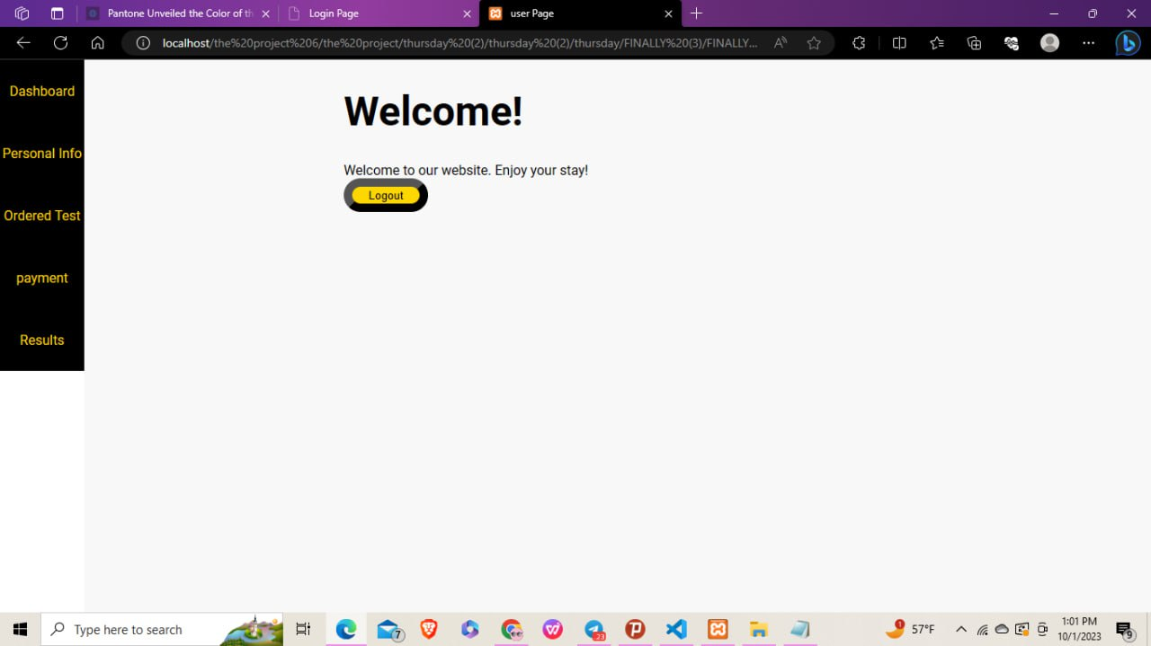

**How to navigate the system after logging in successfully?**

* Clicking the ***logout*** button redirects you right back to the login form
* Click on the ***Patient info*** choice which opens to the personal information of the user

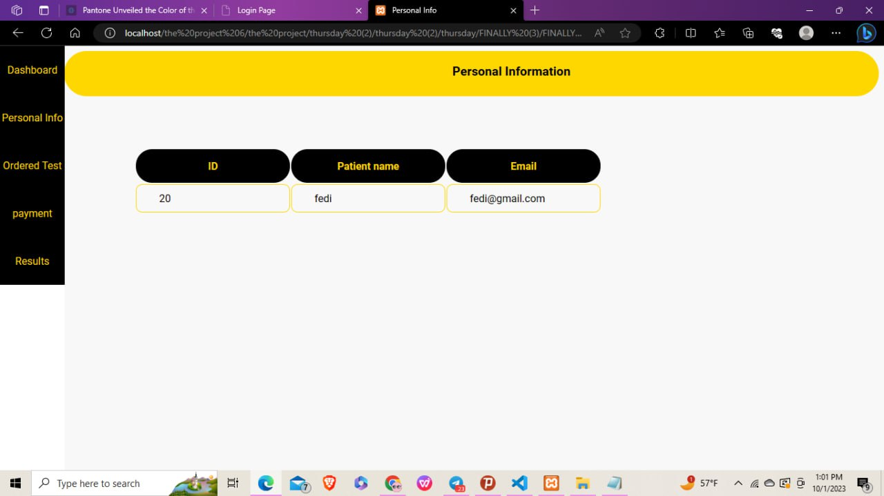

* Click on the ***ordered Test*** choice which views the medical test orders the patient has placed so far

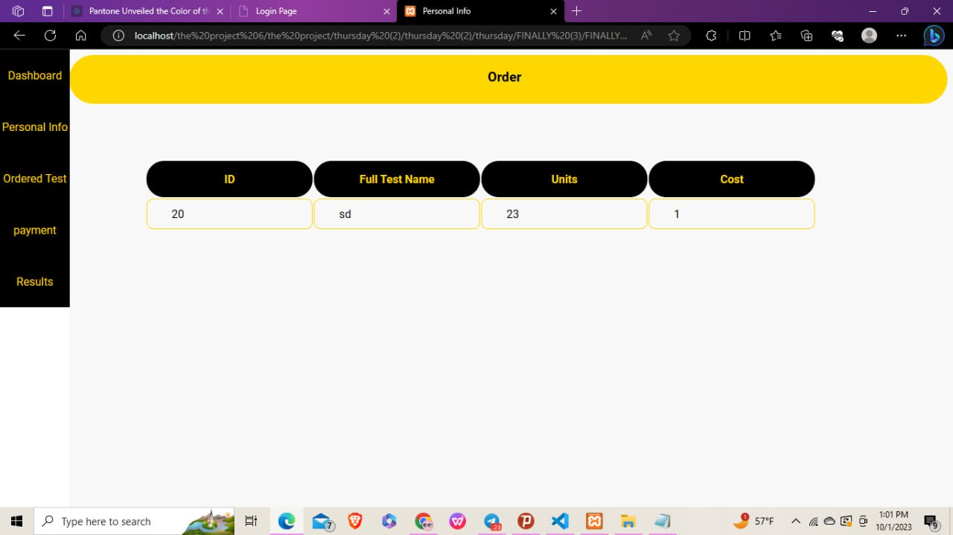

* Click on the ***payment*** choice which views the orders that have been paid for and the ones that haven't been paid for

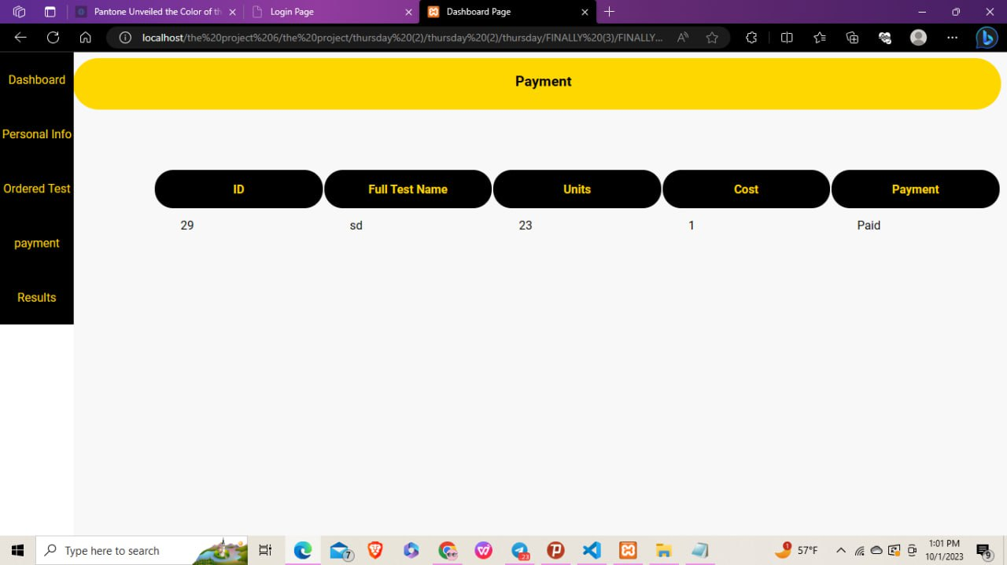

* Click on the ***Results*** choice which views the results of the tests which are specific to the user

